Making Money

If you only have 2p and 5p coins, which sums of money can be made up?
Are there any which cannot? Why?
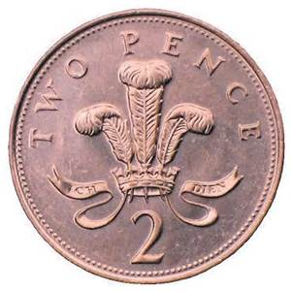
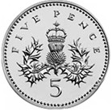

With a supply of 1p, 2p, 5p and 10p coins make a total of 11p in as many different ways as possible.

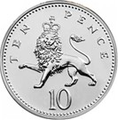
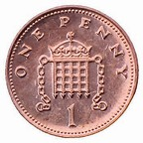

Going Further

If you could use up to 6 coins to make a total of 12p, how many possible ways now?
KS1B
Finding All Possibilities

